Tornadoes Trends in USA

Nirali Pandya

[pandyan@uwindsor.ca](mailto:pandyan@uwindsor.ca)

University of Windsor

Shrey Gupta

[gupta12v@uwindsor.ca](mailto:gupta12v@uwindsor.ca)

University of Windsor

Riyaben Patel

[patel1p2@uwindsor.ca](mailto:patel1p2@uwindsor.ca)

University of Windsor

**ABSTRACT**

Tornadoes are more common in the United States than in any other country. Tornadoes lead to loss and destruction of property with over 1,000 injuries a year. Most deaths are caused by people not following the instructions and unaware of the tornado warning. Hence, it is important to understand the trends of tornadoes in the USA, which can help people to be aware of a probable tornado and take timely action to protect themselves. Trends like months with high tornado numbers, states that are highly affected by tornadoes, number of tornadoes and direction of tornadoes can be used to understand the impact of tornadoes. Use of past data has led to sound results to find the patterns of tornadoes. Various models like regression model, hierarchical Bayesian spatiotemporal model etc. have found the relation of the tornadoes to climate indices in space and time [1]. Such studies can lead to better predictions of tornado occurrence, which can help people to be aware of such calamities, so they can take required precautions. The study in this paper has used a data source from NOAA Storm Prediction Center, which contains data from 1950 to 2017. Data has been analyzed using the data analysis tool, Tableau. Several informative graphs and visualizations have been created, which are rich in information and easy to understand.

**Keywords**

Tornadoes, Tornado Alley, Tornado hazards, Tornadoes in the USA, Tornadoes frequency, EF scale

1. **INTRODUCTION**

Tornadoes are more common in the United States than in any other country, and the U.S. reportedly experiences more than 1,200 tornadoes annually. Most tornadoes occur in the region east of the Rocky Mountains. The Great Plains, the Midwest, the Mississippi Valley and the southern United States are all areas that are vulnerable to tornadoes. Most tornadoes result from thunderstorms with warm, moist air from the Gulf of Mexico and cold, dry air from the north. Tornadoes lead to loss and destruction of property with over 1,000 injuries a year [2]. Hence, it is important to understand various trends of tornadoes in the USA to prepare people against tornadoes. This paper looks at the reported frequencies of tornadoes and their characteristics over the contiguous United States since 1950. The study involves analyzing which states have suffered how many injuries and deaths and what is the proportion of violent and strong tornadoes in those regions. The intention is to understand the nature of tornadoes based on F-scale [3] and its possible impact. Number of tornadoes by state, month, season, hour and F-Scale is also analyzed for better understanding and picturing which regions and which times are more likely to be hit by a tornado and to predict its strength. It will be seen that the number of strong and violent tornadoes has not changed much. For studies involved in this paper, data collected from NOAA Storm Prediction Center has been analyzed using data analysis tool, Tableau, which is a powerful tool and creates effective visualizations.

1. **LITERATURE SURVEY**

Tornado loads become critical in the design of certain structures such as transmission lines and nuclear power stations located in regions prone to severe thunderstorms. The clear majority of line failures are due to the wind that arises from several local wind storms including tornadoes and downbursts. USA faces the highest number of tornadoes with an average of 800 tornadoes per year. Many deaths are caused by tornadoes as people were unaware of them and did not take proper action following warnings. Programs such as NOAA's Weather Ready Nation initiative, had been regulated to reevaluate and improve tornado warning process [4]. Many studies have been done for tornado detection, focused primarily upon the contributions made by weather radar and storm spotters. Prediction of a tornado's precise path and intensity days in advance could allow for evacuation to take place well ahead of storm development and the redeployment of assets needed to support emergency response and recovery. While restrained to less accurate forecasts by the inherent limitations imposed by atmospheric predictability, the last decade has seen a growing recognition of the connection between large-scale patterns and large-scale tornado outbreaks.

The tornado intensity is rated on the Fujita scale (F scale; introduced in 1973) and its successor, the Enhanced Fujita scale (EF scale; adopted by the NWS since 2007), with 0 being the weakest and 5 the strongest [5]. The intensities of tornadoes that occurred before 1973 were rated retrospectively from archived newspaper accounts and photographs [5]. According to previous studies[5], the EF scale was developed, in part, to maintain the climatological consistency over time. Thus, this study considered the F and EF ratings to be equivalent. It has been acknowledged that weak tornadoes (i.e., (E)F0) are reported more frequently over the tornado database; however, the reporting of (E)F1 and stronger tornadoes remains constant and is thus more representative of the actual tornado activity. Therefore, only (E)F1+ tornadoes were retained from the SPC tornado database to offset the general inflation in the reporting of weak tornadoes in this study, which was consistent with the study of Brooks [5]. In total, 30,747 (E)F1+ tornadoes were identified from the 48 states in the contiguous U.S. over 1950–2017.

1. **DATA DESCRIPTION**

Tornado data can tell about the length and stretch of the tornado, the strength of tornado and the states it traversed through. The data [6] consists of the tornado number in sequence with the occurrence of a tornado in each year. It also consists of the date and time of the tornado, the city and the loss caused by it. Start and end latitude and longitude are used to realize the exact distance travelled by a tornado. F-scale denotes the violence and strength of a tornado. The higher the F-scale rating, the more furious the tornado. The data is collected from NOAA Storm Prediction Center for years 1950-2017. Data until 1997 contains the loss field as a range of values whereas after 1997, the data contains the recorded value of the loss. This data set consists of all the tornadoes recorded in the mentioned years.

1. **TORNADOES ANALYSIS AND COMPARISONS**

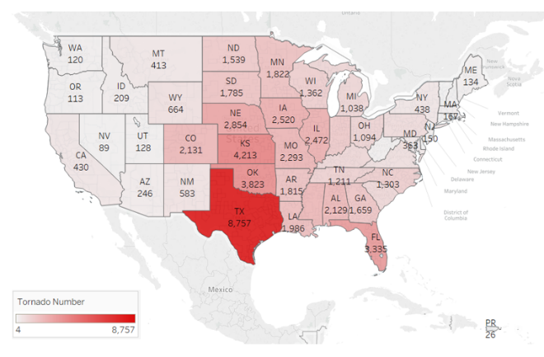

**Figure 1. Total Tornadoes since 1950 to 2017 by state in US**

Figure 1 shows the total number of tornadoes reported in all states of the country during the 67-year period, 1950 through 2017. As you can see in the graph, no state in the US is totally immune to tornadoes, but Texas ranks 1st among all states in the frequency of the tornadoes with 8,757 tornadoes during this period, which is partially due to the state’s size. Moreover, the following states are top five states where tornadoes occur very frequently: Texas, Kansas, Oklahoma, Florida and Nebraska. Thus, the central part of the USA gets more tornadoes because the geographic location of these states is best for tornadoes to occur. The basic ingredients of a tornado are warm, moist air near the ground and dry, cold air aloft. The moist, warm air coming from the Gulf of Mexico to the south collides with the cold, dry air coming from the Rocky Mountains, which creates instability in atmosphere. This provides ideal environmental conditions for the tornadoes’ development more often there than other places on the earth [2].

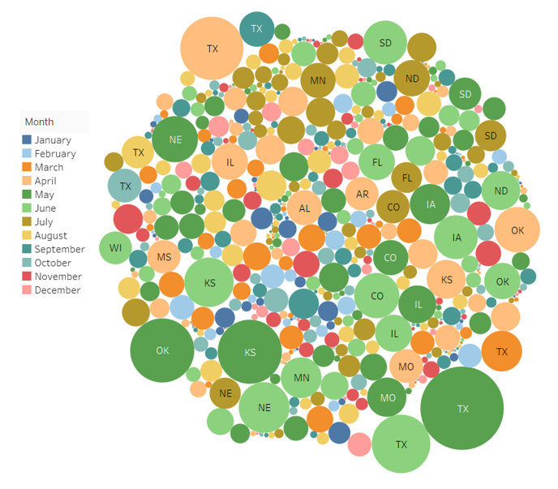

**Figure 2. Tornado frequency with months of year 1950 to 2017**

Tornadoes may occur at any time of the day, month or year in any state of the United States; therefore, there is no specific tornado season [7]. Figure 2 demonstrate the tornado distribution for every month of the year in different states of the country. The size of the circle represents the tornadoes’ frequency and colour stands for months. As the figure shows, each region is affected by potential tornadoes at any time of the year. The frequency of the tornadoes is closely related to the warm season when warm and cold air clash more often [2].

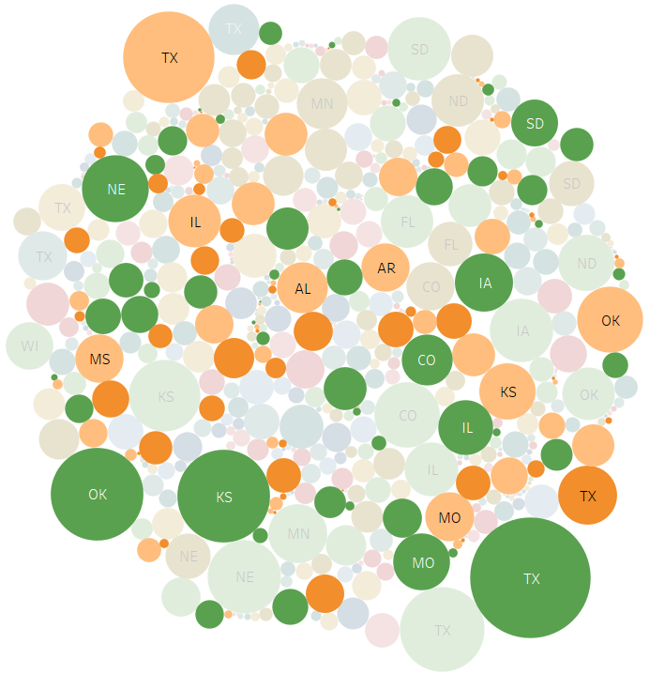

**Figure 3. Tornadoes in spring**

The peak time for tornadoes in the Southeast and South Central is the spring. Figure 3 shows that the highest number of tornadoes occur in May.

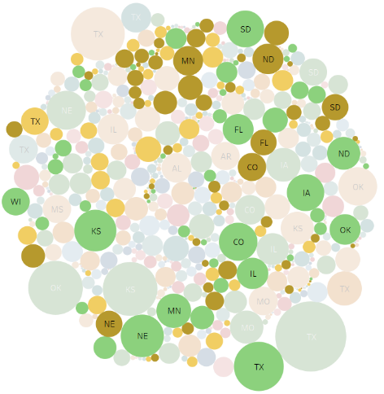

**Figure 4. Tornadoes in summer**

The Northern states are frequent recipients of tornadoes during the fall season. By midsummer, tornadoes may occur throughout the country. This is the time when Tornado Alley becomes active for the tornadoes [8].

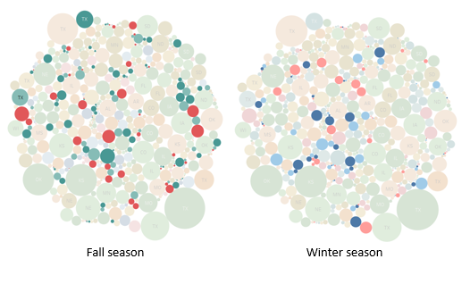

**Figure 5. Tornadoes in fall and winter**

As shown in figure 5, there are fewer tornadoes that occur during fall and winter compared to other seasons during the year. The fewest tornadoes are reported during winter. In the southern states, another peak time for tornadoes is during fall.

Although tornadoes have occurred at any time of the day, peak time for the tornadoes’ occurrence is between 3 PM to 9 PM or in the other words in afternoon or during evening. The reason behind this is that tornadoes consume their energy from solar heating and latent heat released upon water vaporization.

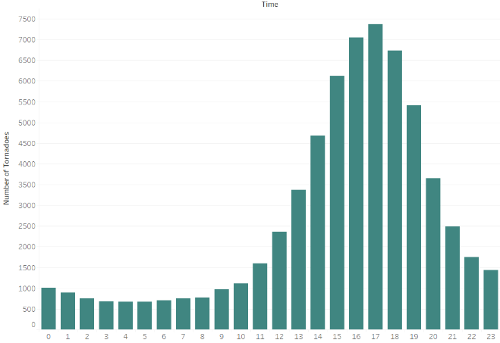

**Figure 6. Tornado occurrence by hour of day for the US**

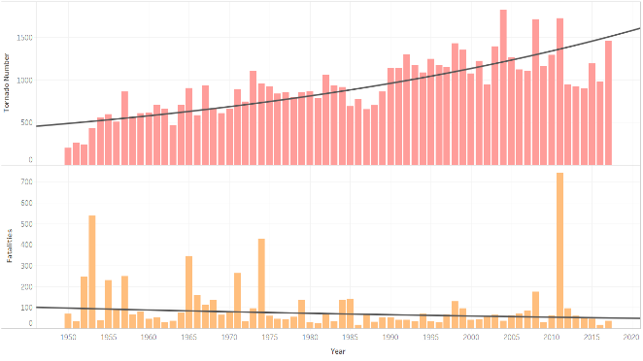

**Figure 7. Tornadoes and loss occurred per year since 1950 to 2017**

Figure 7 displays the number of tornadoes and fatalities during the past 67 years. The number of reported tornadoes is growing, and fatalities caused by the tornadoes are declining with the time as per the trend analysis represented by the black line. The growth period for reported tornadoes is because of public awareness and technological revolution that provided increased publicity by television news and graphical illustration of tornadoes and their hazards. The increase in reported tornado numbers over the past several decades corresponds to the increasing population, increased National Doppler radar coverage and greater attention to the tornado reporting. This can mislead about the increasing trend of tornado frequency. In contrast, the fatalities happening due to tornadoes are decreased because of public awareness and use of latest technologies used for weather prediction prior to the tornadoes’ occurrence, which warn people in advance [3].

Tornadoes are categorized according to the Enhanced Fujita (EF) scale by their magnitude and damage rating. The EF scale replaced the former F scale in February 2007 [7].

**Table 1. Tornadoes Classification**

|  |  |  |
| --- | --- | --- |
| **Type** | **EF scale** | **Damage** |
| Weak | EF-0 (65-85 mph) | Light |
| EF-1 (86-110 mph) | Moderate |
| Strong | EF-2 (111-135 mph) | Considerable |
| EF-3 (136-165 mph) | Severe |
| Violent | EF-4 (166-200 mph) | Devastating |
| EF-5 (201+ mph) | Incredible |

The tornadoes with EF scale can be analyzed to better understand the trend in tornado frequency. These tornadoes might have been reported before Doppler radar came into practice for weather forecasting [3].

Figure 8 shows the percentage distribution of tornadoes by F-scale over the 67-year period. During this period, about 80% of tornadoes are reported as weak tornadoes (EF-0 and EF-1) and damage due to these types of tornadoes are light or moderate. Moreover, very few violent tornadoes are rated as EF-4 and EF-5, which is around 1% of all tornadoes reported. From the study, each year 1,000 or more additional weak tornadoes may occur, which are never documented.

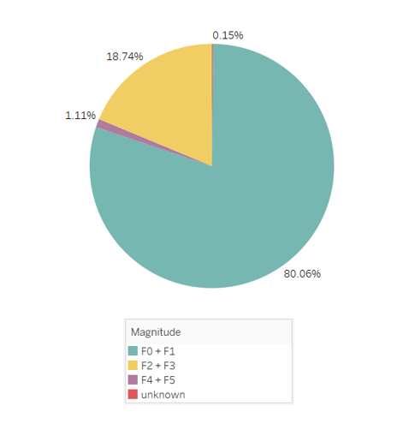

**Figure 8. Percentage of tornadoes, 1950-2017, by F-scale**

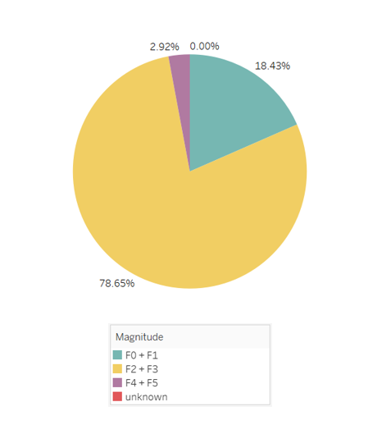

**Figure 9. Percentage of tornado-related property loss, 1950-2017, by F-scale**

As there are fewer tornadoes that occurred with F2 and F3 compare to F0 and F1 tornadoes, strong tornadoes are highly responsible for probably 80% of the property damage in the United States. On the other side, there are large number of weak tornadoes but as discussed earlier these tornadoes are slight in wind speed so never cause many hazards.

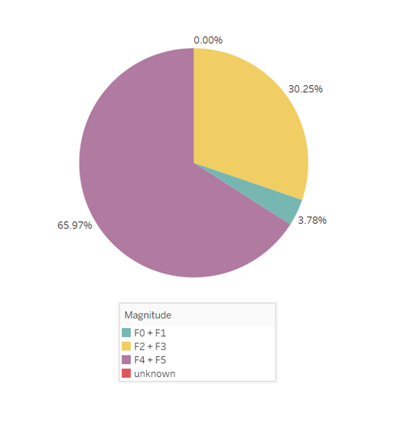

**Figure 10. Percentage of tornado-related death, 1950-2017, by F-scale**

Above pie chart revels that even though there are very few violent tornadoes happened in the past 67 years, but they caused extensive fatalities which is almost 66%. This happened because of the high magnitude (wind speed) tornadoes contain.

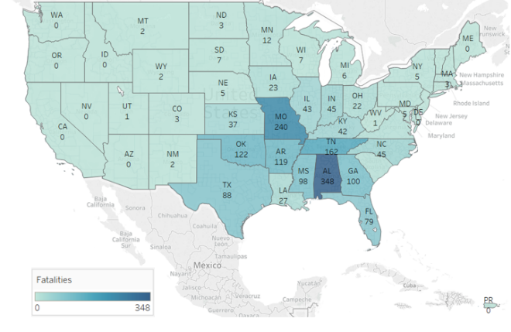

**Figure 11. Tornadoes-related fatalities by state in US since 1950 to 2017**

Above visual illustrates that Alabama is the leader among all states in the country for the death occurred due to tornadoes since past 67-year period [9]. While comparing figure 1 and figure 11, the question arises that there are more tornadoes occurred in Texas, but Alabama ranks no. 1 in tornadoes-related fatalities. The root cause behind this is Alabama has been a victim of most violent tornadoes compare to other states since past years.

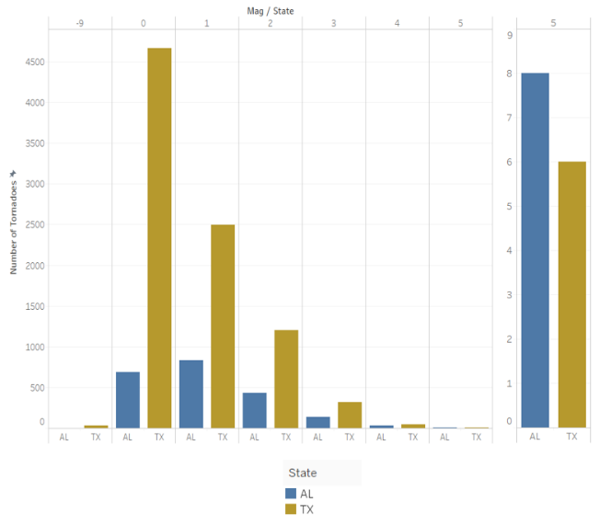

**Figure 12. Tornadoes of F0 and F5 in Texas and Alabama**

As shown in figure 12, above 50% of the tornadoes came in Texas are of F0 which rarely cause death and Alabama has affected by 8 strongest intensity tornadoes, more than any other state in the US. This is the reason why more Alabamians have died in tornadoes. It seems natural correlation, but another answer is high percentage of people in Alabama living in mobile homes. Additionally, Alabamians may not receive proper waring about tornadoes in advance or have access to shelter because of Alabama has more rural areas. Tornadoes in Alabama are dark clouds instead of recognizable funnel. Most of the states have different peak tornadoes season while Alabama is the state where tornadoes occur at any month. From above all the facts, it can be examined that tornadoes intensity more affects the property rather than the frequency of the tornadoes. In a nutshell, more fatalities in Alabama is because of frequency of tornadoes, density of population [9].

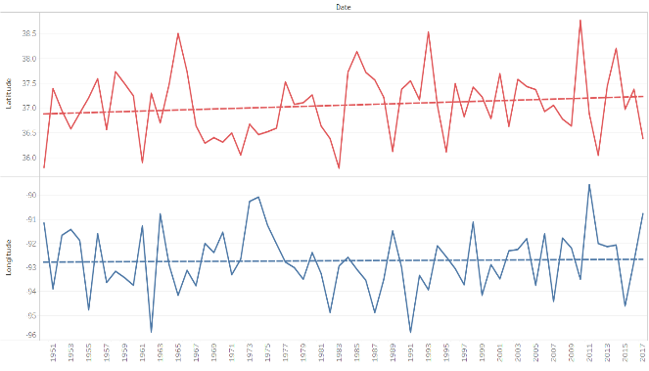

**Figure 13. Tornadoes direction since 1950 to 2017**

From the figure 13, it can be analyzed that tornadoes are moving from south west to north east or we can say west to east. It is observed that not all the tornadoes move in same direction. The growing frequency of certain tornado specific weather patterns are the reason for this. Furthermore, tornadoes direction is directly affected by the Coriolis effect, which creates the tornadoes rotating anti-clockwise in the northern hemisphere [10].

A close up of a map

Description generated with very high confidence

**Figure 14. Tornadoes-related fatalities comparison with high scale tornadoes (> EF3) by month**

The study includes that, tornadoes with stronger winds tends to cause more deaths and injuries. That means, tornadoes with scale EF0 represents minimum damage and EF5 represents destruction. From the figure 14, we can say that high scale tornadoes occurred in the spring, particularly during the months of April and May, which indicates effect of tornadoes on humans is higher in spring. According to the data analysis, the number of EF4 and EF5 scale tornadoes occurred in April is high, which tends to high fatalities compare to other months.

1. **RESULTS**

Though tornadoes have been known to move in every direction, it is found that average tornadoes move in the direction from southwest to northeast. They tend to occur at any hour on the day or night, but they are most likely to occur between 3 and 9 pm. Due to the temperature patterns in the USA, spring is the peak period for the tornadoes formation. By analyzing the trend of number of tornadoes in various states of the country, most tornadoes occur in the region known as Tornado Alley. There is no officially defined ‘Tornado Alley’, it is the broadest area which stretches from North Texas to Canada with its core centered on Oklahoma, Kansas and northern Texas.

With the advancement of technology and based on factors primarily upon population distribution, severe weather climatology, topography and proximity to other radars, more tornadoes have been reported than it used to be. This furthers to creation of proper data set, which leads to more precise trends and tornadoes prediction. With this advancement, people get timely warning of tornadoes, which saves many lives.

Our study shows that Alabama faces the maximum number of deaths even though Texas is the state with maximum number of tornadoes. This is due to strong tornadoes intensity(EF-Scale) in Alabama.

# CONCLUSION

Tornadoes become less effective over the past 67 years in the USA, with the annual national tornadoes fatality rate reduction. This reduction is due to the efforts carried out by the National Weather services to issue more accurate and timely tornadoes waring and to increase the awareness about tornadoes by educating the public about tornado safety [11]. From the above analysis we can predict the behavior and characteristics of tornadoes in USA, which helps to save human life.

# REFERENCES

|  |  |
| --- | --- |
| [1] | L. Guo, K. Wang and H. B. Bluestein. |
| [2] | W. contributors, "Tornadoes in the United States," Wikipedia, The Free Encyclopedia, 14 June 2018. [Online]. Available: https://en.wikipedia.org/w/index.php?title=Tornadoes_in_the_United_States&oldid=845857782. |
| [3] | D. McCarthy and J. Schaefer , "TORNADO TRENDS OVER THE PAST THIRTY YEARS," 2004. |
| [4] | J. Brotzge and W. Donner, "The Tornado Warning Process: A Review of Current Research, Challenges, and Opportunities," *AMS,* no. 10.1175/BAMS-D-12-00147.1, 2013. |
| [5] | C. A. Doswell, H. E. Brooks and N. Dotzek, "On the implementation of the enhanced Fujita scale in the USA," *Elsevier,* vol. 93, pp. 554-563, 2009. |
| [6] | "Strom Predection Center," NOAA's National Weather Services, 15 May 2017. [Online]. Available: https://www.spc.noaa.gov/gis/svrgis/. |
| [7] | U. D. o. Commerce, "http://www.crh.noaa.gov," 20 July 2009. [Online]. Available: http://www.crh.noaa.gov/Image/dvn/downloads/quickfacts_Tornadoes.pdf. |
| [8] | J. Belles, "Your Average Tornado Risk By Month," weather.com, 18 April 2017. [Online]. Available: https://weather.com/science/weather-explainers/news/tornado-risk-by-month. |
| [9] | K. Kazek, "Why do more Alabamians die in tornadoes than residents of any other state?," AL.com, 19 April 2015. [Online]. Available: https://www.al.com/news/index.ssf/2015/04/why_do_more_alabamians_die_in.html. |
| [10] | "Do Tornadoes Always Twist in the Same Direction?," wonderopolis.org, [Online]. Available: https://wonderopolis.org/wonder/do-tornadoes-always-twist-in-the-same-direction. |
| [11] | K. M. SIMMONS and D. SUTTER, "WEATHER AND FORECASTING," *Tornado Warnings, Lead Times, and Tornado Casualties: An Empirical Investigation,* vol. 23, no. 10.1175/2007WAF2006027.1, 2008. |
| [12] | L. V. WOLFORD, "Tornado Occurrences in the United States," Washington, DC, 1960. |
| [13] | M. K. Tippett, C. Lepore and J. E. Cohen, "More tornadoes in the most extreme U.S. tornado outbreaks," *Science,* vol. 354, no. 6318, pp. 1419-1423, 2016. |
| [14] | S. J. Childs and R. S. Schumacher, "Cold-season Tornado Risk Communication: Case Studies from November 2016 to February 2017," *AMS,* 2018. |
| [15] | T. W. Moore, "On the temporal and spatial characteristics of tornado days in the United States," *ELSEVIER,* vol. 184, pp. 56-65, 2017. |
| [16] | T. A. Coleman, K. R. Knupp, J. Spann, J. B. Elliott and B. E. Peters, "The History (and Future ) of Tornado warning dissemination in the United States," *AMS,* pp. 567-582, 2011. |
| [17] | T. A. Coleman and P. G. Dixon, "An Objective Analysis of Tornado Risk in the United States," *AMS,* 2014. |
| [18] | T. J. Farney and P. G. Dixon, "Variability of tornado climatology across the continental United States," *Royal Meteorological Society,* vol. 35, pp. 2993-3006, 2015. |
| [19] | S. Addy and A. Ijaz, "Preliminary Economic and Fiscal Impacts of the April 27, 2011 Tornadoes on Alabama," Center for Business and Economic Research, 2011. |